Classification of Computer Networks

1. Local Area Network (LAN)
   1. Restricted to one local area
   2. Definition: Is a computer network that interconnects computers within a limited area such as a residence, school, laboratory, university campus or office building.
   3. 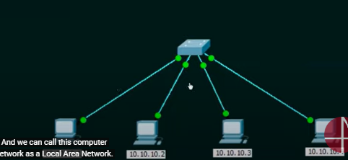
   4. LAN-DEVICES:
      1. Wired LAN (Ethernet - hub, switch)
      2. Wireless LAN (WIFI)
2. Metropolitan Area Network (MAN)
   1. Definition: Is a cımputer network that interconnects users with computer resources in a geographic region the size of a metropolitan area(city).
   2. Local areas are connected to each other in a city.
   3. MAN devices:
      1. Switches/Hub: to establish the metropolitan area network.
      2. Routers/Bridges: To connect 2 local area networks
   4. 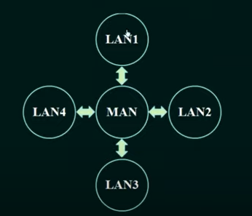
3. Wide Area Network (WAN)
   1. Definition: Is a telecommunications network that extends over a large geographical area for the primary purpose of computer networking.
   2. WAN devices:
      1. All end devices and intermediary devices
   3. 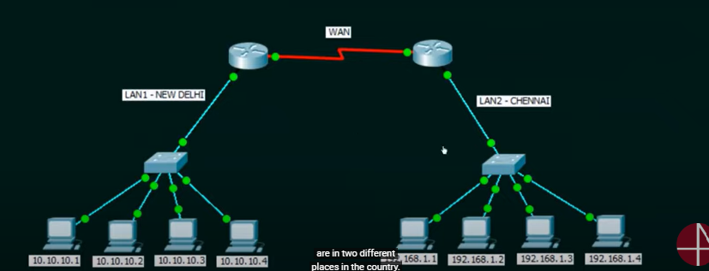
4. The Internet
   1. World wide communication

New Trends:

1. Bring your own device (BYOD): Employees can bring their own device and connect to the office network and access the office data.
2. Online collaboration: Ex → Zoom meetings
3. Cloud computing: It is the on demand availability of computer system resources, especially data storage and computing power, without direct active management by the user. (like google drive)